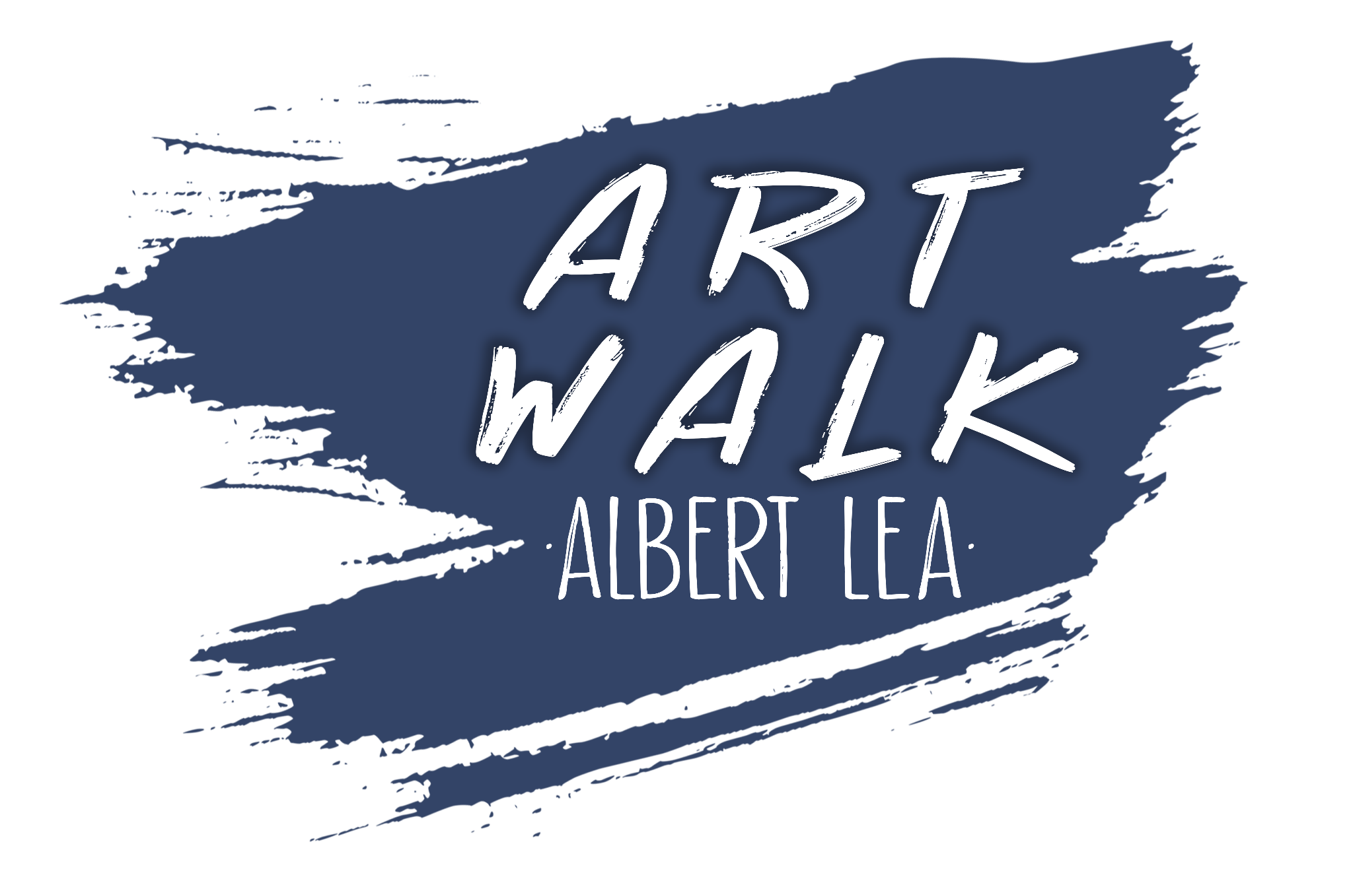

ART SCULPTURE CALL - Spring 2023

Art Walk Albert Lea is excited to accept applications for its first sculpture collection for Spring 2023. Albert Lea is approximately 18,000 people and is home to a historic downtown, recreational lakes, and thriving businesses.
Albert Lea is known for being a walk-friendly community. Paths around the lake and an accessible downtown were the winning choices for displaying sculptures. Sculptures don’t need to fit any sort of theme or vision, but must fit the size requirements listed below. Contact maggie@explorealbertlea.com with questions and submissions. We are excited to see your proposal and to hopefully see your art on the streets soon!

Timeline
Initial Submissions Due April 21st (Phase 1 of approval)
Final completed physical submissions Due June 30th (Phase 2 of approval)
Art sculpture placement August 25th, 2023 with ribbon cutting to follow

Dimensions
Artwork max height < 84”
Artwork max width at base < 18”
Artwork max width < 54”

Material
Weather safe in all 4 seasons
Examples: stone, metal, ceramic…
The bottom of the art piece needs to have the ability to be welded onto the metal
pedestal plate

Hazards
All moving components will need jury approval
No sharp edges or similar risk

Lease
Art sculpture will be leased “Art Walk Albert Lea” for 12 months
Artist Stipend available upon jury approval
Sculpture will be posted for sale
AWAL will receive 30% proceeds of sale

Jury Process
Art needs to meet our “public appropriateness” guidelines
-No overtly sexual, political, or profane images/language
Initial Submissions Due April 21st (Phase 1 of approval)
ie. drawings, photos, etc.
Final completed physical submissions Due June 30th (Phase 2 of approval)
ie. jury needs to review art in person

Liability Release
As soon as artwork is handed off to Art Walk Albert Lea, the artist is released from responsibility of the piece. No compensation if the piece is damaged or lost.

Submission Information
Submit your proposal to Maggie Moller at Art Walk Albert Lea by April 21st, 2023.
maggie@explorealbertlea.com

